**Name – Pramod Kumar**

**Reg - 201FA07083**

**Section – “B”**

**Subject – WT**

ASSIGNMENT:-

**(1).**

**ASSIGNMENT1.HTML :-**

<!DOCTYPE html>

<html lang="en">

<head>

<meta charset="UTF-8" />

<meta http-equiv="X-UA-Compatible" content="IE=edge" />

<meta name="viewport" content="width=device-width, initial-scale=1.0" />

<title>Assignment1</title>

<style>

#I { color: red;

}

</style>

</head>

<body>

<ol>

<li id="a">Apple</li>

<li id="B">orange</li>

<li id="I">papaya</li>

<li id="L">quick</li>

<li id="KK">range</li>

<li id="KI">disc</li>

<li id="JU">ulod</li>

<li id="OL">cuds</li>

<li id="IO">rice</li>

<li id="OOO">tusjfKNOAI</li>

<li id="111">AHDBUISEDFK</li>

<li id="LOP">JFSODKBJV</li>

<li id="POP">FJVNSOLN</li>

<li id="I14">dytuhkj</li>

<li id="LOPI">EFKNMVSO</li>

<li id="KUMA">dytuhkj</li>

<li id="HIDSNA">LDFJNCODL</li>

<li id="KIOOL">KDFNAOIED</li>

<li id="OLPOPP">KFNSEIPODL</li>

<li id="OPIP">BFRUOALJDF </li> </ol> </body> </html>

OUTPUT:-

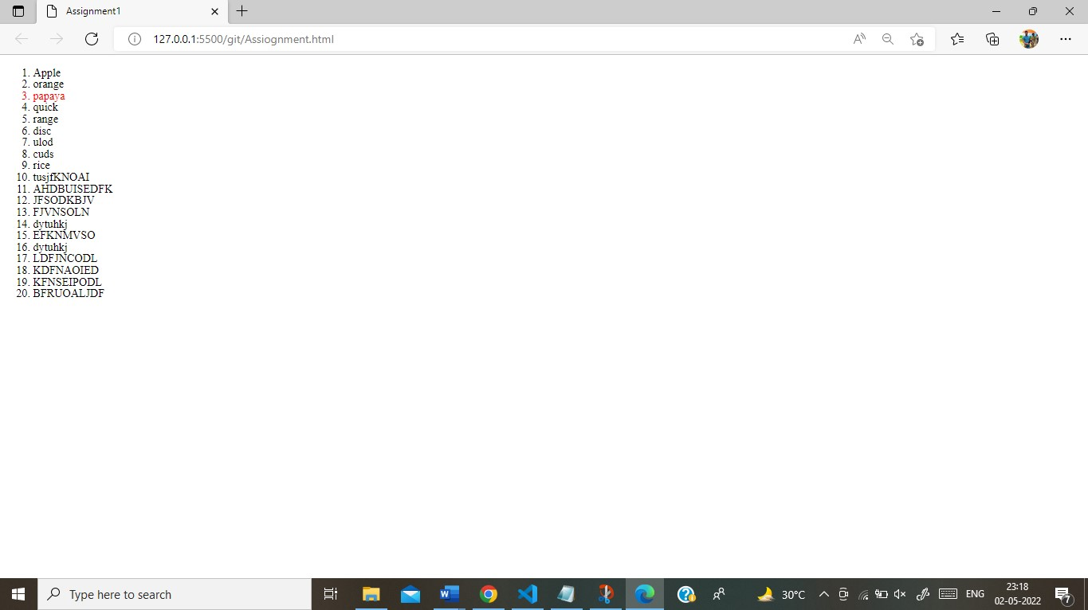

**(2).**

# ASSIGNMENT2.HTML :-

<!DOCTYPE html>

<html lang="en">

<head>

<meta charset="UTF-8" />

<meta http-equiv="X-UA-Compatible" content="IE=edge" />

<meta name="viewport" content="width=device-width, initial-scale=1.0" />

<title>Document</title>

<style>

.KK:nth-of-type(3),

.KK:nth-of-type(4), .KK:nth-of-type(5) {

color: red;

}

</style>

</head>

<body>

<ol>

<li >Apple</li>

<li >orange</li>

<li class="KK">papaya</li>

<li class="KK">quick</li>

<li class="KK">range</li>

<li >disc</li>

<li >ulod</li>

<li >cuds</li>

<li >rice</li>

<li >tusjfKNOAI</li>

<li >AHDBUISEDFK</li>

<li >JFSODKBJV</li>

<li >FJVNSOLN</li>

<li >dytuhkj</li>

<li >EFKNMVSO</li>

<li >dytuhkj</li>

<li >LDFJNCODL</li>

<li >KDFNAOIED</li>

<li >KFNSEIPODL</li>

<li >BFRUOALJDF </li>

</ol>

</body>

</html>

OUTPUT:-

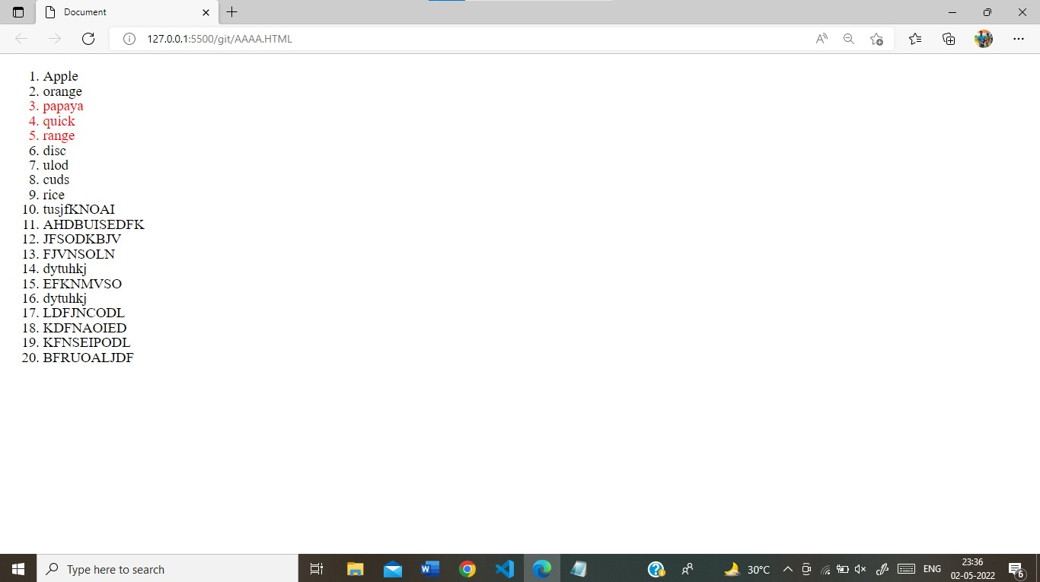

**(3).**

# ASSIGNMENT3.HTML :-

<!DOCTYPE html>

<html lang="en">

<head>

<meta charset="UTF-8" />

<meta http-equiv="X-UA-Compatible" content="IE=edge" />

<meta name="viewport" content="width=device-width, initial-scale=1.0" />

<title>Document</title>

<style> a:nth-of-type(1) { border: 2px solid wheat; border-radius: 5px; background-color: rgb(245, 219, 184);

color: white; text-decoration: none;

}

a:nth-of-type(2) { border: 2px solid rgb(245, 179, 197); background-color: rgb(241, 111, 117); border-radius: 5px; color: white; text-decoration: none;

} body { display: flex; justify-content: space-between; align-items: center;

flex-direction: column;

}

</style>

</head>

<body>

<a

href="[https://www.google.com/search?q=google&rlz=1C1CHBF_enIN981IN981&oq=goo](https://www.google.com/search?q=google&rlz=1C1CHBF_enIN981IN981&oq=google&aqs=chrome..69i57j46i67i131i199i433i465j35i39j0i67i131i433l2j0i67j0i67i131i433j0i67j0i67i433.2782j0j15&sourceid=chrome&ie=UTF-8)

[gle&aqs=chrome..69i57j46i67i131i199i433i465j35i39j0i67i131i433l2j0i67j0i67i131i433j0](https://www.google.com/search?q=google&rlz=1C1CHBF_enIN981IN981&oq=google&aqs=chrome..69i57j46i67i131i199i433i465j35i39j0i67i131i433l2j0i67j0i67i131i433j0i67j0i67i433.2782j0j15&sourceid=chrome&ie=UTF-8)

[i67j0i67i433.2782j0j15&sourceid=chrome&ie=UTF-8"](https://www.google.com/search?q=google&rlz=1C1CHBF_enIN981IN981&oq=google&aqs=chrome..69i57j46i67i131i199i433i465j35i39j0i67i131i433l2j0i67j0i67i131i433j0i67j0i67i433.2782j0j15&sourceid=chrome&ie=UTF-8)

>google</a

>

<br />

<br />

<a href="[https://www.youtube.com/watch?v=gQ5qVtoLMk4"](https://www.youtube.com/watch?v=gQ5qVtoLMk4)>youtube</a>

<!-- Code injected by live-server -->

<script type="text/javascript"> // <![CDATA[ <-- For SVG support if ('WebSocket' in window) {

(function () { function refreshCSS() { var sheets = [].slice.call(document.getElementsByTagName("link")); var head = document.getElementsByTagName("head")[0]; for (var i = 0; i < sheets.length; ++i) { var elem = sheets[i]; var parent = elem.parentElement || head; parent.removeChild(elem); var rel = elem.rel;

if (elem.href && typeof rel != "string" || rel.length == 0 || rel.toLowerCase() ==

"stylesheet") { var url = elem.href.replace(/(&|\?)_cacheOverride=\d+/, ''); elem.href = url + (url.indexOf('?') >= 0 ? '&' : '?') + '_cacheOverride=' + (new Date().valueOf());

}

parent.appendChild(elem);

} } var protocol = window.location.protocol === 'http:' ? 'ws://' : 'wss://'; var address = protocol + window.location.host + window.location.pathname + '/ws'; var socket = new WebSocket(address); socket.onmessage = function (msg) { if (msg.data == 'reload') window.location.reload(); else if (msg.data == 'refreshcss') refreshCSS();

};

if (sessionStorage && !sessionStorage.getItem('IsThisFirstTime_Log_From_LiveServer'))

{ console.log('Live reload enabled.'); sessionStorage.setItem('IsThisFirstTime_Log_From_LiveServer', true);

}

})(); } else { console.error('Upgrade your browser. This Browser is NOT supported WebSocket for LiveReloading.');

}

// ]]>

</script></body>

</html>

OUTPUT:-

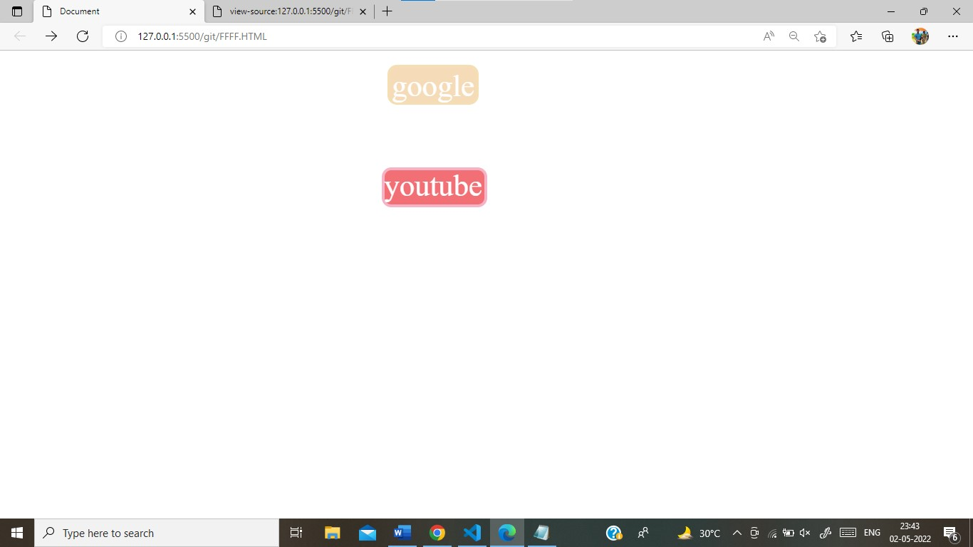

**(4).**

# ASSIGNMENT4.HTML :-

<!DOCTYPE html>

<html>

<head> <style> a:visited { color: red;

}

a:link { color: yellow;

}

a:hover { color: rgb(214, 200, 172);

}

a:active { color: blue;

}

</style>

</head>

<body>

<a href="https://www.GOOGLE.com/"> GOOGLE</a>

</body>

</html>

OUTPUT:-

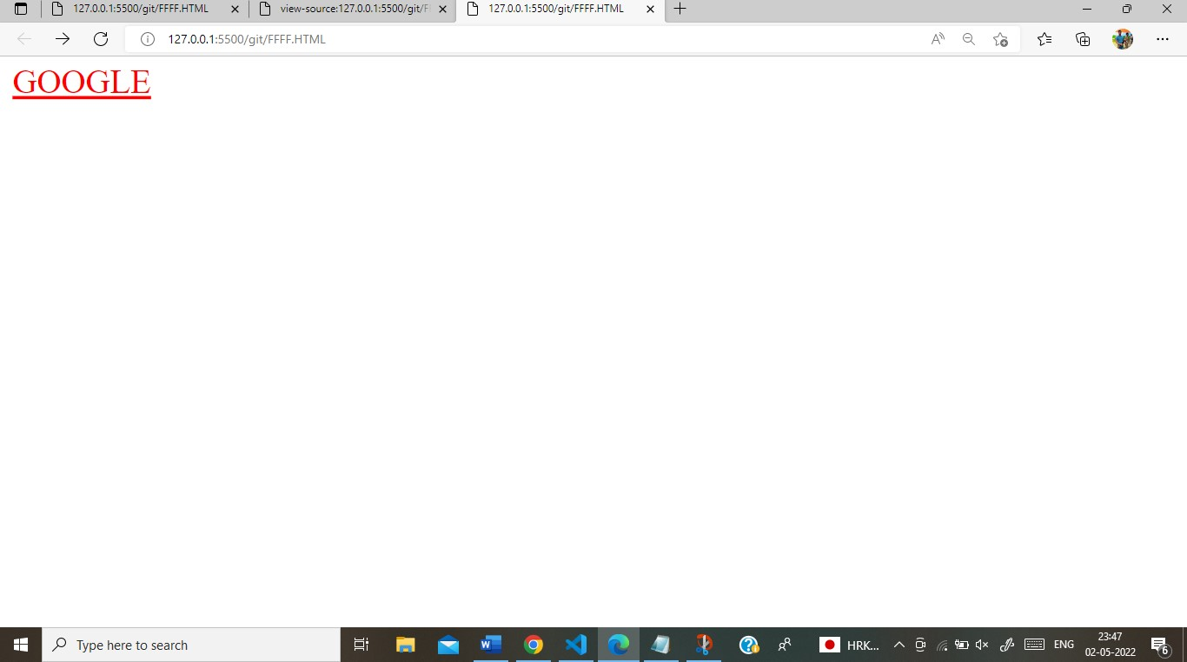

**(5).**

# ASSIGNMENT5.HTML :-

<!DOCTYPE html>

<html>

<head> <style> a:visited { color: red;

}

a:link { color: yellow;

}

a:hover { color: rgb(214, 200, 172);

}

a:active { color: blue;

}

</style>

</head>

<body>

<a href="https://www.GOOGLE.com/"> GOOGLE</a>

</body>

</html>

OUTPUT :-

